Glasgow Lands Registration
c/o Maggie Carchrie, BATD
53 Loon Place
South Windsor, CT 06074

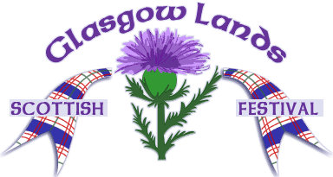
2017 Highland Dance Competition
USE-0108

Northampton, MA

July 15, 2017

Look Park
300 North Main St.
Florence (Northampton), Massachusetts 01062

About Look Park: More than 150 acres of wooded picnic areas including water spray park and pedal boats (www.lookpark.org)
Accommodations and Camping
Many options can be found in the greater Northampton, Westfield, and Springfield areas.
More info:www.glasgowlands.org
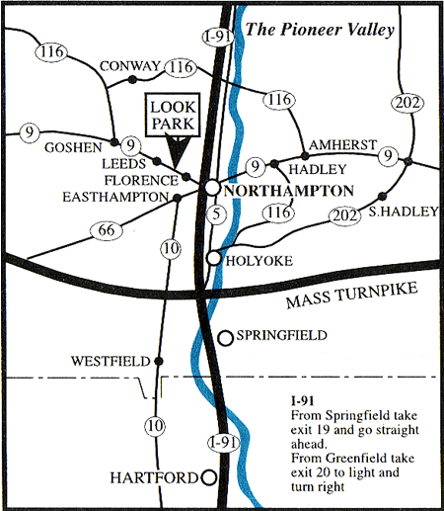
From the South
I-91 N to Exit 19, go straight ahead for 3.4 miles. Look Park is directly ahead.
From the North
I-91 S to Exit 20. Turn right at light onto Bridge Road. Follow for 2.4 miles; Look Park is directly ahead.
From the East or West
Mass Pike, I-90 to Exit 4, I-91 N. Follow directions from the South.
Events
Primary
- 16 Pas de Basques
- Pas de Basques and Highcuts (x4)
- Fling (4)
- Sword (2&1)

Beginner
- Lilt (4)
- Fling (4)
- Sword (2&1)
- Seann Truibhas (3&1)

Novice
- Lilt (4)
- Flora (4)
- Fling (4)
- Sword (2&1)
- Seann Truibhas (3&1)

Intermediate
- Hornpipe (4)
- Lilt (4)
- Flora (4)
- Fling 4)
- Seann Truibhas (3&1)

Premier
- Hornpipe (4)
- Village Maid (4)
- Blue Bonnets (4)
- Fling (4)
- Laddie (4)

Registration for Primary, Beginner, Novice at
9 AM with dancing to commence at 9:30 AM.

Intermediate and Premier registration begins at 12:30 PM with dancing starting at 1 PM.

Age groups determined by number of entries. Oldest Premier group receives cash prizes. Trophies awarded to all age groups except Primary.
General Information

Organizers: Maggie Carchrie
Judge: Lindsay Recknagel
Piper: Thomas Leigh

1. This event is governed by SOBHD Rules. The judge's decision is final.
2. Dancers must show 2017 FUSTA or ScotDance card at registration.
3. First to enter, last to compete.
4. The organizers reserve the right to make changes in the best interest of the competition.
Questions? maggie@mermaid-productions.com

Fees:
Primary $16
Beginner/Novice/Intermediate $20
Premier $24

Sponsorship:
Sponsor a Trophy $40
Sponsor a Medal set $25

In honor/memory of Name/Company:

_________________________________________________

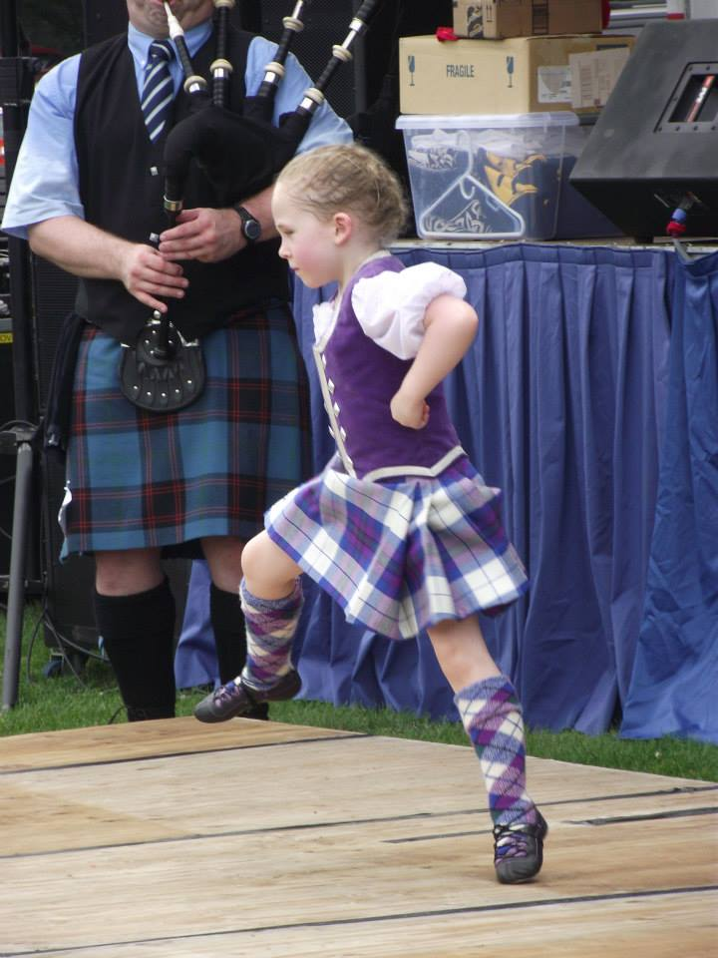

Entry Form
Closing Date: July 1, 2017

Name:______________________________________
Street: ______________________________________
City: _______________ State: ____ Zip: ________
E-mail: _____________________________________
DoB: ____________ Age (on 7/15/17): _____
Class: ____________ FUSTA#: _______________
Event #s: ___________________________________
Total Enclosed in US Dollars: $_________ $___

Detach this section and mail to:

Maggie Carchrie, BATD
53 Loon Place
South Windsor, CT 06074

Checks payable to:
Glasgow Lands Scottish Festival

Please include entry form, check, and Self Addressed Stamped Envelope (SASE). Entries without SASE will not be processed. No field entries will be accepted.

I understand that the Glasgow Lands Scottish Festival has no responsibility for injury or loss incurred to the above competitor in attending or participating in the dance competition on July 15, 2017. I agree that photographs taken in connection with my participation may be used in publicity by GLSF.

Signature: __________________________________ (Parent or guardian if under 18)

